**To be filled by the Student**

|  |  |
| --- | --- |
| Assignment Number | 2 |
| Name | Nazim Zerrouki |
| UWNetID | 1373533 |

### Part A: What is the rationale behind the cost function for Logistic Regression ?

### 

### Part B: How is updated during gradient descent when using logistic regression?

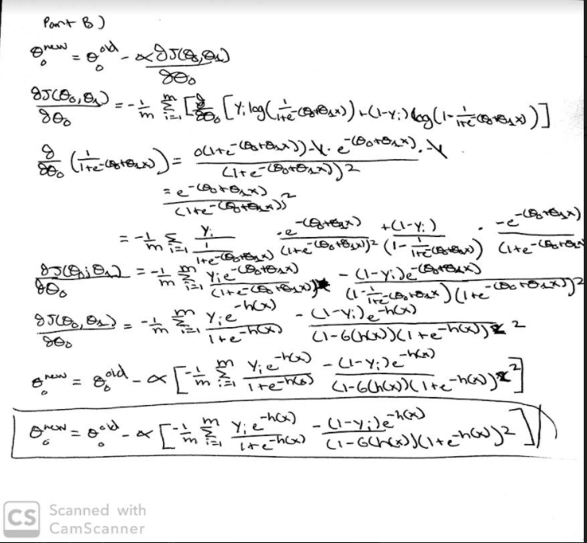

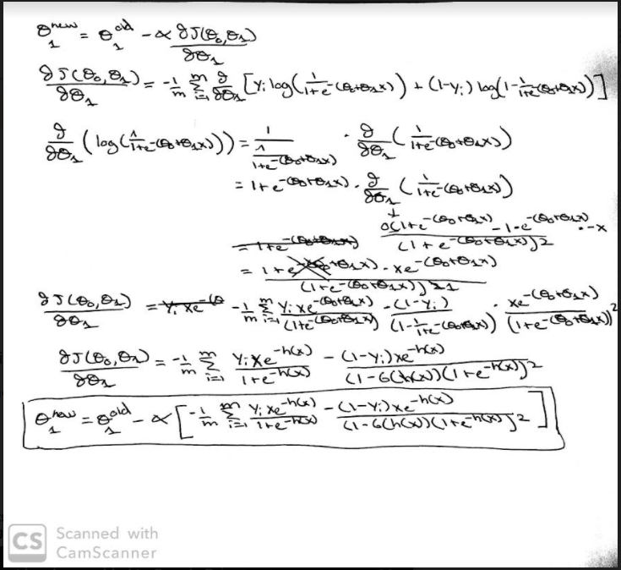

### Part C: Build a logistic regression classifier for each of the 3 iris flower classes.

* Assignment2PartC.ipynb

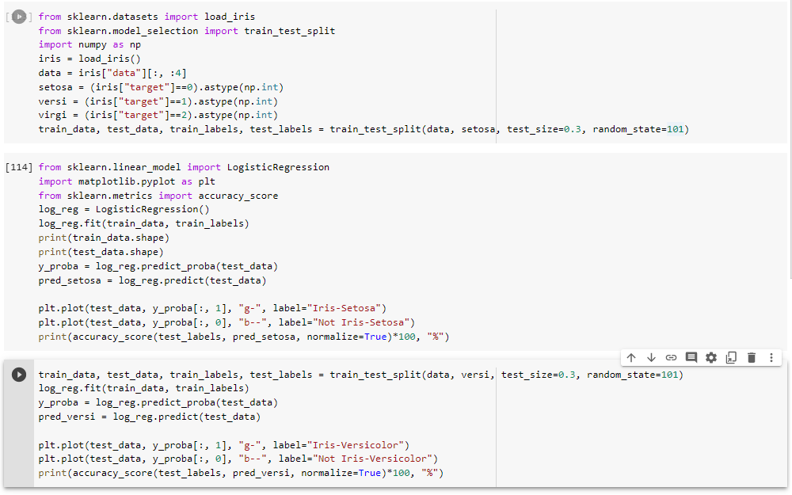

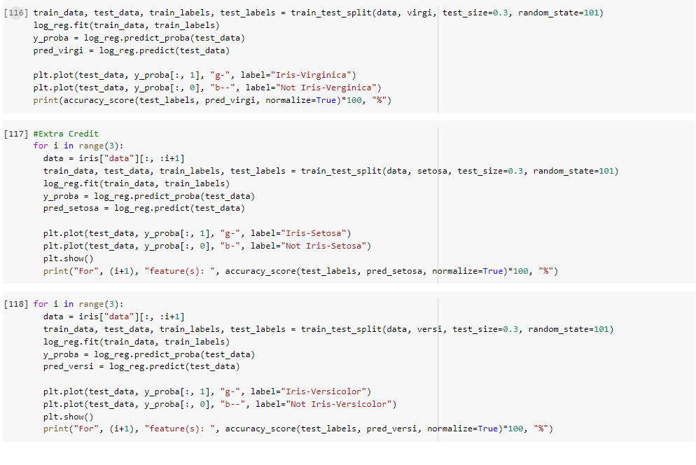

* Execution output showing Accuracy results for the 3 classifiers

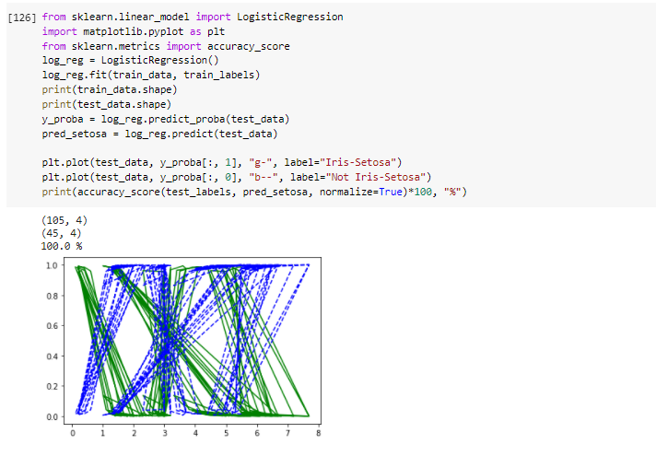

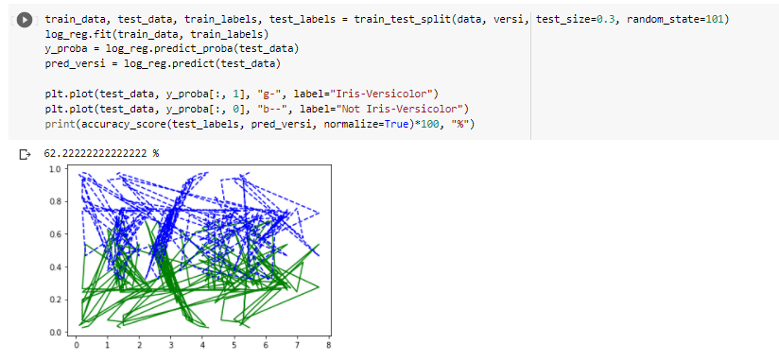

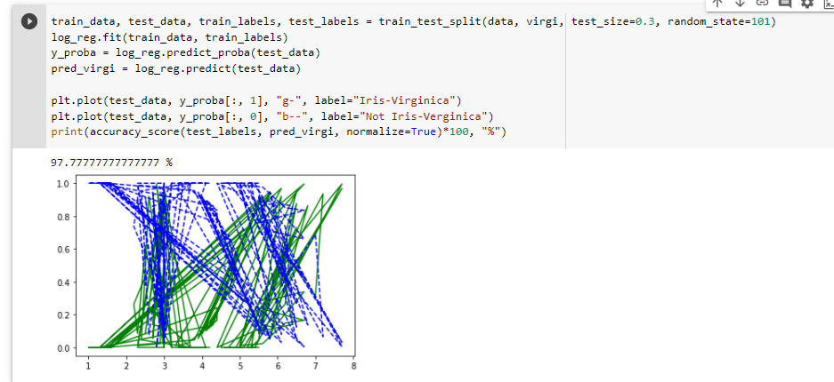

* Extra Credit

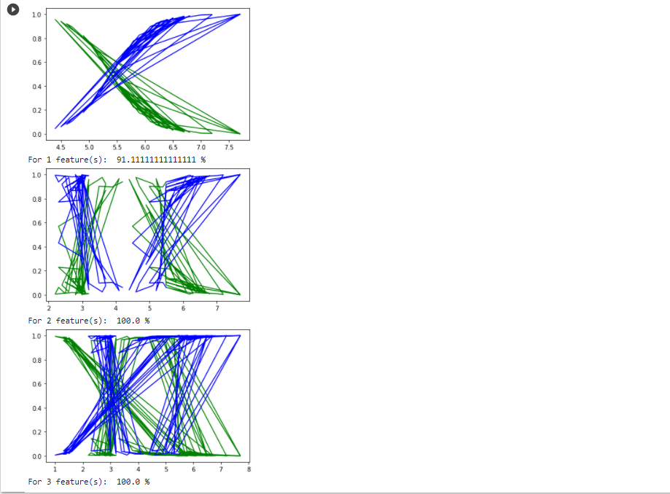

The result found above is due to some underfitting found in the first graph. Because there is only 1 feature, there is a simplified model of the data. This can be shown because there are a few linear lines found in the graph. With 2 or 3 features, there is no underfitting which gives us 100% accuracy just like before.

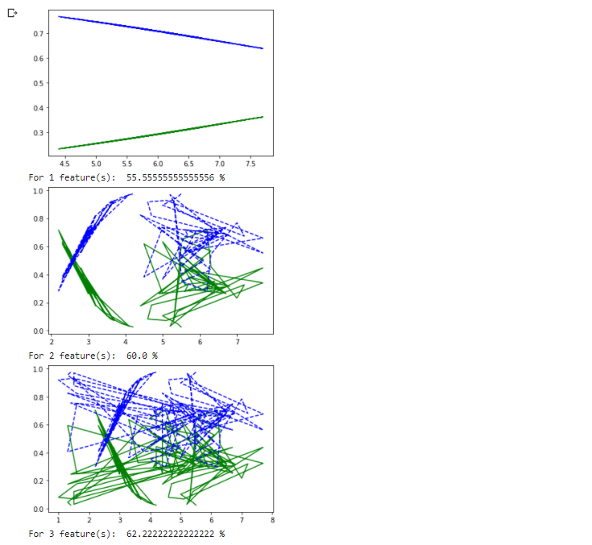

The accuracy remains the same between 3 and 4 features, but the accuracy is reduced for 1 and 2 features. This is likely due to some underfitting. With 1 feature, there is only 1 linear line to represent the data which is a gross oversimplification of the data. With 2 features, some data is clearly lost compared to the graphs with 3 and 4 features despite being less generalized than the first graph.

**Grading Rubric (For Grader Use Only):**

|  |  |  |  |
| --- | --- | --- | --- |
| Task | Max Score | Score Received | Comments |
| Proper Submission on canvas | 4 |  |  |
| Proper Hard Copy submission | 0 |  |  |
| Proper Naming and format of Files | 1 |  |  |
| Part A – Correct Rationale for cost function | 15 |  |  |
| Part A – Detailed Description of Rationale | 10 |  |  |
| Part B – Correct update rule and calculation for | 12.5 |  |  |
| Part B – Correct update rule and calculation for | 12.5 |  |  |
| Part B – Legibility of calculation | 5 |  |  |
| Part C – Loading Iris Data (Code) | 5 |  |  |
| Part C – Train-Test-Split (Code) | 5 |  |  |
| Part C – Setosa Classifier (Code) | 7 |  |  |
| Part C – Versicolor Classifier (Code) | 7 |  |  |
| Part C – Virginica Classifier (Code) | 6 |  |  |
| Part C – Accuracy Computation [code] | 5 |  |  |
| Part C – Display Accuracy [output] | 5 |  |  |
| Extra Credit |  |  |  |
| Feature Change for Setosa | 2.5 |  |  |
| Feature Change for Versicolour | 2.5 |  |  |
| Total | 100 (105 possible) |  |  |

Grader Comments